MAIN PROJECT REPORT

Bank Marketing Campaign Analysis Using Python

Project Domain: Banking and Financial Services
Project Type: Exploratory Data Analysis (EDA)
Programming Language: Python
Tools and Libraries: Google Colab, Pandas, NumPy, Matplotlib, Seaborn, Plotly

Submitted by: Remya V
Course: Data Analytics DA54
Project Title: Bank Marketing Campaign Analysis –
Customer Subscription Prediction and Business Insights

INDEX
- Abstract
- Introduction
- Problem Statement
- Objectives of the Project
- Dataset Description
- Tools and Technologies Used
- Data Cleaning and Preprocessing
  - 7.1 Loading the Dataset
  - 7.2 Checking Missing Values
  - 7.3 Handling Missing Values
  - 7.4 Standardizing Categorical Data
  - 7.5 Checking Duplicate Records
  - 7.6 Outlier Analysis
- Exploratory Data Analysis (EDA)
  - 8.1 Target Variable Analysis
  - 8.2 Customer Age Analysis
  - 8.3 Bank Balance Analysis
  - 8.4 Subscription Rate by Occupation
  - 8.5 Subscription Rate by Marital Status
  - 8.6 Subscription Rate by Education
  - 8.7 Monthly Subscription Rate Analysis
  - 8.8 Campaign Contact Frequency Analysis
  - 8.9 Call Duration Analysis
  - 8.10 Subscription Rate by Housing Loan Status
  - 8.11 Correlation Analysis
- Visualization Techniques
- Overall Key Findings
- Business Insights
- Business Recommendations
- Limitations of the Analysis
- Future Scope
- Final Conclusion
- References

1. Abstract
The Bank Marketing Campaign Analysis project aims to understand customer behavior and identify factors associated with term deposit subscriptions. The project uses Python to clean, transform, analyze, and visualize banking customer data.
The original dataset contains 4,521 records and 17 columns describing customer demographics, financial information, and marketing campaign activities. After handling missing values in the target variable, 4,517 records were retained for the main analysis.
Exploratory data analysis was performed to examine subscription distribution, customer age, bank balance, occupation, marital status, education, monthly campaign performance, contact frequency, call duration, housing loan status, and correlations between numerical variables.
The results show that 520 customers subscribed to term deposits, representing 11.51% of the analyzed dataset. Retired customers and students had the highest observed subscription rates among occupational groups. Customers without housing loans also showed a higher subscription rate than customers with housing loans.
The project demonstrates how data analysis can support customer segmentation, marketing campaign evaluation, and data-driven business decisions.

2. Introduction
Banks use marketing campaigns to promote financial products such as term deposits. However, not all customers respond positively to marketing calls. Understanding the characteristics and behavior of customers who subscribe can help banks improve campaign effectiveness.
Data analytics provides tools to identify patterns in customer demographics, account balances, previous interactions, and marketing outcomes.
This project applies Python-based data analysis techniques to a bank marketing dataset. The analysis focuses on identifying patterns associated with successful subscriptions and developing practical recommendations for improving marketing strategies.

3. Problem Statement
The bank conducts marketing campaigns to encourage customers to subscribe to term deposits. However, a large proportion of contacted customers do not subscribe.
The main problem is to understand the factors associated with subscription decisions and identify opportunities to improve campaign conversion rates.
The project addresses the following questions:
- How many customers subscribed to term deposits?
- What are the age and bank balance characteristics of customers?
- Which occupational groups have higher subscription rates?
- How do marital status and education relate to subscription behavior?
- How does subscription performance vary by month?
- How do campaign contact frequency and call duration differ between subscribers and non-subscribers?
- How is housing loan status associated with subscription rates?
- What relationships exist among numerical variables?
- What business recommendations can be developed from the findings?

4. Objectives

4.1 Primary objective
To analyze bank marketing data using Python and identify customer and campaign characteristics associated with term deposit subscriptions.

4.2 Secondary objectives
- Understand the structure and quality of the dataset.
- Handle missing values and standardize categorical data.
- Identify duplicate records and examine outliers.
- Perform descriptive statistical analysis.
- Analyze the distribution of the target variable.
- Compare subscription rates across customer groups.
- Create visualizations using Matplotlib, Seaborn, and Plotly.
- Interpret the results and develop actionable business recommendations.
- Establish a foundation for future subscription prediction modeling.

5. Dataset Description
The project uses the file banking.csv.

5.1 Dataset overview
Description | Details
Original number of records | 4,521
Number of columns | 17
Records retained after removing missing target values | 4,517
Target variable | y
Target categories | yes, no
Data types | Numeric and categorical
Analysis approach | Exploratory Data Analysis

5.2 Description of dataset columns
Column | Description
age | Customer age
job | Customer occupation
marital | Marital status
education | Education level
default | Credit default status
balance | Average yearly account balance, as represented in the dataset
housing | Housing loan status
loan | Personal loan status
contact | Contact communication type
day | Day of the month when the customer was contacted
month | Month of the last contact
duration | Duration of the last contact in seconds
campaign | Number of contacts during the current campaign
pdays | Days since the customer was previously contacted; special values require careful interpretation
previous | Number of contacts before the current campaign
poutcome | Outcome of the previous marketing campaign
y | Whether the customer subscribed to a term deposit

6. Tools and Technologies Used

Python
Python was used for data manipulation, statistical analysis, and visualization.

Pandas
Pandas was used to load the dataset, inspect data types, handle missing values, group records, calculate statistics, and calculate subscription rates.

NumPy
NumPy supports numerical calculations and data processing.

Matplotlib
Matplotlib was used to create charts and customize their titles, labels, and layouts.

Seaborn
Seaborn was used to create statistical visualizations, including histograms, box plots, and correlation heatmaps.

Plotly
Plotly was used to create interactive charts, including pie charts, bar charts, histograms, and line charts.

Google Colab
Google Colab provided the notebook environment for executing Python code and documenting the results.

7.Data Loading and Initial Inspection

7.1 Loading the dataset
The CSV file was loaded into a Pandas DataFrame.
import pandas as pd
import numpy as np

df = pd.read_csv("/content/main.project.dataset.banking.csv")

print(df.head())
print(df.shape)
print(df.info())
The original dataset contained 4,521 records and 17 columns.

8. Data Cleaning and Preprocessing
Data cleaning is an essential step because missing values and inconsistent categories can affect the reliability of the analysis.

8.1 Checking missing values
print(df.isnull().sum())
The initial inspection identified missing values in the following columns:
- age: 2 missing values
- marital: 2 missing values
- y: 4 missing values

8.2 Handling missing target values
Rows with missing target values were removed because the subscription outcome was required for the main analysis.
df = df.dropna(subset=["y"])
After removing these four records, 4,517 records remained.

8.3 Imputing missing numerical values
The missing values in age were filled using the median.
df["age"] = df["age"].fillna(df["age"].median())
The median was selected because it is less affected by extreme values than the mean.

8.4 Imputing missing categorical values
Missing values in marital were filled using the mode.
df["marital"] = df["marital"].fillna(
df["marital"].mode()[0]
)
The mode represents the most frequently occurring category.

8.5 Standardizing categorical data
Categorical values were standardized to avoid inconsistencies caused by extra spaces or differences in letter case.
object_cols = df.select_dtypes(
include=["object"]
).columns

df[object_cols] = df[object_cols].astype(‘string’)

8.6 Checking duplicate records
print("Duplicate removed:{ df.duplicated().sum()}”)
df = df.drop_duplicates()
The earlier inspection reported no duplicate rows.

8.7 Outlier analysis
Outliers were examined using descriptive statistics, the interquartile range method, and box plots.
The analysis identified extreme observations in variables such as age, balance, duration, campaign, pdays, and previous.
Outliers were not automatically removed because some extreme values may represent genuine customer behavior. Special values in pdays and previous also require domain-specific interpretation.
Data cleaning outcome: The main analysis proceeded with 4,517 records after missing target values were removed and missing age and marital values were imputed. Any additional transformations should be documented according to the final executed notebook.

9. Exploratory Data Analysis and Business Insights

9.1 Analysis of the target variable
The target variable y identifies whether a customer subscribed to a term deposit.
Observed results:
Subscription status | Number of customers | Percentage
No | 3,997 | 88.49%
Yes | 520 | 11.51%
Total | 4,517 | 100%
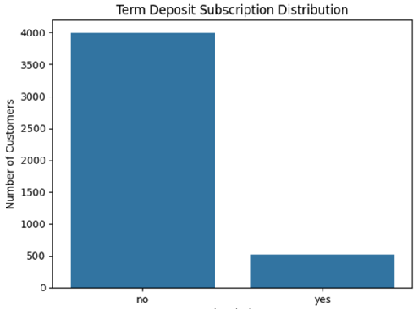
Business insight
Only 11.51% of customers subscribed, while 88.49% did not. This indicates a low observed conversion rate and an imbalance between the two subscription outcomes.
Recommendation
The bank should examine customer segments, campaign timing, previous contact outcomes, and communication practices to identify opportunities for improving conversion rates.

9.2 Customer age analysis
The descriptive statistics for age were:
Statistic | Value
Number of observations | 4,517
Mean age | 41.16 years
Standard deviation | 10.56 years
Minimum age | 19 years
First quartile | 33 years
Median age | 39 years
Third quartile | 49 years
Maximum age | 87 years
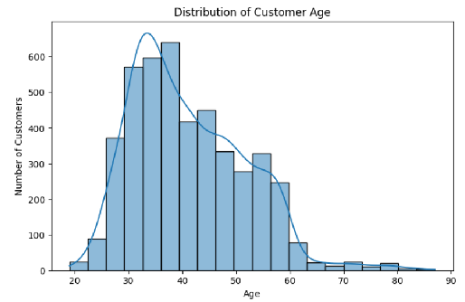
Business insight
The average age was approximately 41 years, and the middle 50% of customers were between 33 and 49 years old.
Recommendation
The bank can compare subscription rates across age groups to identify responsive customer segments. Marketing strategies should be based on observed subscription patterns rather than age alone.

9.3 Bank balance analysis
Statistic | Value
Mean balance | 1,413.96
Standard deviation | 2,978.33
Minimum balance | -3,313
First quartile | 69
Median balance | 444
Third quartile | 1,477
Maximum balance | 71,188
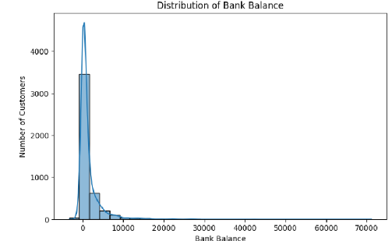

Business insight
The mean balance is substantially higher than the median, indicating a right-skewed distribution. Some customers have much higher balances than the majority.
Recommendation
Use balance segmentation to investigate whether subscription rates differ across financial groups. The median provides a useful measure of the typical account balance in this distribution.

9.4 Subscription rate by Job
The calculated subscription rates were:
Job category | Subscription rate
Retired | 23.58%
Student | 22.62%
Unknown | 18.42%
Management | 13.44%
Housemaid | 12.50%
Admin | 12.16%
Self-employed | 10.93%
Technician | 10.81%
Unemployed | 10.16%
Services | 9.11%
Entrepreneur | 8.93%
Blue-collar | 7.29%
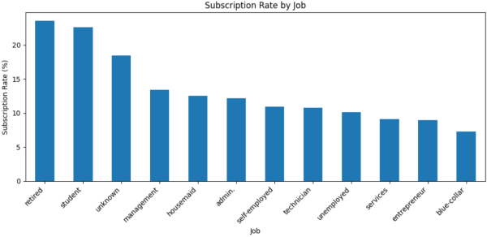
Business insight
Retired customers recorded the highest observed subscription rate at 23.58%, followed by students at 22.62%. Blue-collar workers recorded the lowest rate at 7.29%.
Recommendation
The bank should investigate the needs and preferences of retired customers and students and test targeted marketing campaigns for these groups. Customer group sizes and campaign costs should also be considered.

9.5 Subscription rate by marital status
Marital status | Subscription rate
Divorced | 14.58%
Single | 13.90%
Married | 9.91%

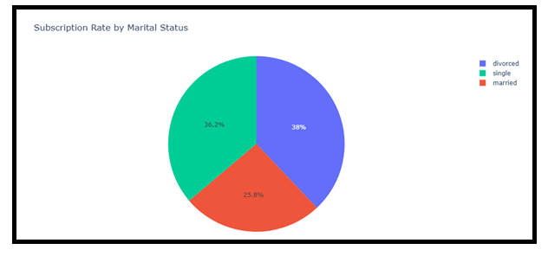
Business insight
Divorced customers had the highest subscription rate at 14.58%, followed by single customers at 13.90%. Married customers had a lower rate of 9.91%.
Recommendation
The bank can examine differences in customer preferences across marital-status groups and test relevant campaign messages. Marital status should be used as an analytical segment, not as a cause of subscription behavior.

9.6 Subscription rate by education
Education level | Subscription rate
Tertiary | 14.25%
Secondary | 10.63%
Unknown | 10.16%
Primary | 9.44%
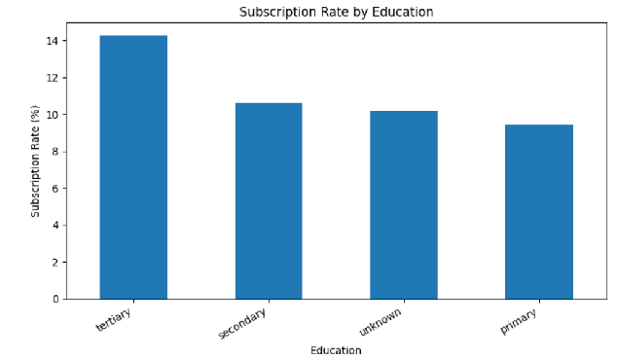
Business insight
Customers with tertiary education had the highest observed subscription rate at 14.25%, while customers with primary education had the lowest rate at 9.44%.
Tertiary education refers to higher education, such as college or university-level study.
Recommendation
The bank should provide clear and accessible information about term deposits to customers across all education levels. Missing education information should be investigated to improve customer data quality.

9.7 Monthly subscription rate
The observed subscription rates by month were:
Month | Subscription rate
January | 10.81%
February | 17.19%
March | 42.86%
April | 19.11%
May | 6.65%
June | 10.38%
July | 8.65%
August | 12.48%
September | 31.37%
October | 46.25%
November | 10.03%
December | 45.00%
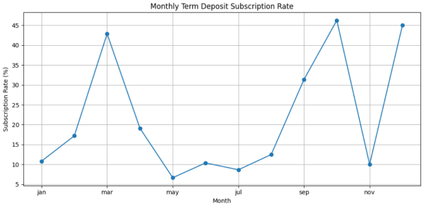
Business insight
October had the highest observed subscription rate at 46.25%, followed by December at 45.00% and March at 42.86%. May had the lowest rate at 6.65%.
This indicates substantial differences in observed conversion rates across months.

Recommendation
The bank should investigate campaign timing, customer selection, and contact strategies in high-performing months. Monthly sample sizes must be checked before assuming that these patterns represent reliable seasonal effects.

9.8 Campaign contact frequency by subscription outcome
The descriptive statistics showed:
Statistic | Not subscribed | Subscribed
Number of customers | 3,997 | 520
Mean campaign contacts | 2.86 | 2.28
Median campaign contacts | 2 | 2
Maximum campaign contacts | 50 | 24
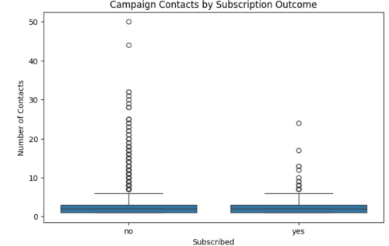
Business insight
Customers who subscribed received an average of 2.28 contacts during the current campaign, compared with 2.86 contacts among customers who did not subscribe.
This suggests that successful subscriptions were associated with fewer campaign contacts on average. Repeated calls alone may not improve conversion.
Recommendation
Evaluate the effectiveness of repeated contacts and monitor the conversion rate by contact attempt. Avoid unnecessary calls that increase operational costs or negatively affect customer experience.

9.9 Call duration by subscription outcome
The median call durations were:
Subscription status | Median duration | Approximate minutes
No | 167 seconds | 2.8 minutes
Yes | 444 seconds | 7.4 minutes
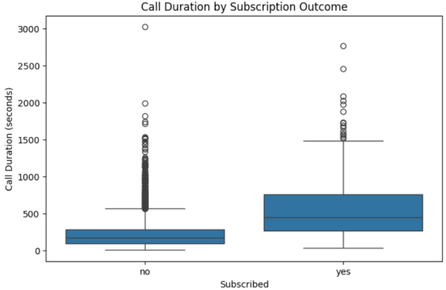
Business insight
Customers who subscribed had a median call duration of 444 seconds, compared with 167 seconds for customers who did not subscribe.
The subscriber median was approximately 2.66 times the non-subscriber median. The box plot also showed substantial variation and unusually long calls in both groups.
This suggests that longer calls are associated with successful subscriptions, potentially reflecting greater engagement or more detailed discussions.
Recommendation
Train marketing staff to explain deposit benefits clearly and answer customer questions. Analyze successful calls to identify effective communication practices. Call duration should be considered an indicator of engagement rather than a target to maximize.

9.10 Subscription rate by housing loan status
Housing loan | Subscription rate
No | 15.36%
Yes | 8.56%
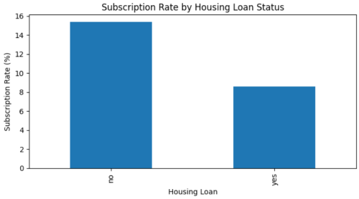
Business insight
Customers without housing loans had a subscription rate of 15.36%, compared with 8.56% for customers with housing loans.
This suggests that housing loan status is associated with differences in term deposit subscription behavior. Existing financial commitments may be one factor worth investigating.
Recommendation
Examine subscription behavior across financial segments and develop relevant product communication strategies. The results do not establish that having a housing loan directly causes a lower subscription rate.

9.11 Correlation analysis
The correlation heatmap examined relationships among seven numerical variables.
Variable pair | Correlation | Interpretation
pdays and previous | +0.58 | Moderate positive correlation
day and campaign | +0.16 | Weak positive correlation
age and balance | +0.08 | Very weak positive correlation
campaign and duration | -0.07 | Very weak negative correlation
campaign and pdays | -0.09 | Very weak negative correlation
age and duration | Approximately 0.00 | Almost no linear correlation
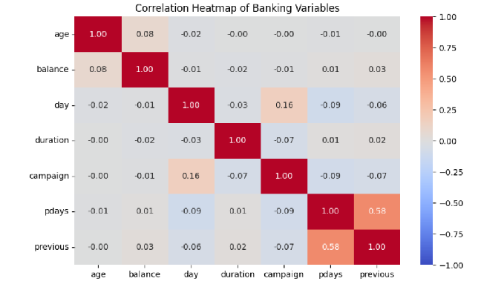
Business insight
The strongest observed relationship was between pdays and previous, with a correlation coefficient of approximately 0.58. Most other numerical variable pairs had weak linear relationships.
Recommendation
The bank should combine demographic, financial, and campaign-related information when analyzing customer behavior. The target variable y should also be examined separately to understand which factors are associated with subscription outcomes.
The special meaning of values in pdays must be considered before interpreting the relationship between previous contact timing and contact frequency.

10. Visualization Techniques
The project uses several visualization techniques to make the results easier to understand.
Visualization | Purpose
Count plot or pie chart | Compare subscribed and non-subscribed customers
Histogram | Understand age and balance distributions
Bar chart | Compare subscription rates by job, education, marital status, and housing loan status
Line chart | Examine monthly subscription rates
Box plot | Compare campaign contacts and call duration across subscription outcomes
Correlation heatmap | Examine relationships between numerical variables
Interactive Plotly charts | Explore data using hover information and interactive controls
These visualizations help communicate analytical results and identify patterns that may not be obvious from tables alone.

10. Overall Key Findings
The main findings of the project are summarized below.
- The cleaned analysis dataset contained 4,517 customers.
- Only 520 customers subscribed, giving an overall subscription rate of 11.51%.
- Retired customers had the highest observed subscription rate among job categories at 23.58%.
- Customers with tertiary education had a subscription rate of 14.25%.
- Divorced customers had a subscription rate of 14.58%, the highest among the marital-status groups.
- Customers without housing loans had a higher subscription rate than customers with housing loans.
- October had the highest observed monthly subscription rate at 46.25%.
- Subscribers had a median call duration of 444 seconds, compared with 167 seconds for non-subscribers.
- Subscribers received fewer campaign contacts on average than non-subscribers.
- Most numerical variable pairs had weak correlations, while pdays and previous showed a moderate positive correlation.

11. Business Recommendations
Based on the exploratory analysis, the following actions are recommended.

11.1 Improve customer segmentation
Segment customers using occupation, age, education, account balance, loan status, and previous campaign history. Evaluate the conversion rate and business value of each segment.

11.2 Optimize marketing campaigns
Investigate why some months have higher observed subscription rates. Compare campaign costs, customer volumes, and conversion rates before allocating resources to particular periods.

11.3 Improve customer communication
Use the call-duration analysis to investigate successful customer interactions. Train staff to communicate product benefits effectively and address customer questions.

11.4 Manage contact frequency
Evaluate conversion rates across different contact attempts. Reduce repeated unsuccessful calls when further contact is unlikely to provide sufficient benefit.

11.5 Improve data quality
Continue monitoring missing values, inconsistent categories, duplicate records, and unusual numerical observations. Preserve valid observations and document any exclusions or transformations.

11.6 Develop a predictive model
As a future extension, build a classification model to identify customers with a higher likelihood of subscribing. Possible algorithms include Logistic Regression, Decision Tree, and Random Forest.
Model performance should be evaluated using precision, recall, F1-score, ROC-AUC, and a confusion matrix. Because the target is imbalanced, accuracy alone may not be sufficient.
For predictions made before a marketing call, exclude duration because it is known only after the call. Any model must also use a suitable validation procedure to avoid data leakage.

12. Limitations of the Analysis
The project has several limitations that should be considered when interpreting the findings.
- The analysis identifies associations and descriptive patterns; it does not establish causation.
- Monthly subscription rates may be affected by differences in the number and type of customers contacted.
- Some categories contain unknown values, which can limit interpretation.
- Outliers may represent genuine customer behavior and should not be removed without investigation.
- The correlation heatmap covers numerical variables only and does not directly measure their relationship with the categorical target y.
- A predictive model has not been evaluated in the analyses reported here.
- Call duration cannot be used as a pre-call predictor because it becomes known only after the call.
These limitations should be addressed in future statistical analysis and predictive modeling.

13. Future Scope
The project can be extended in the following ways:
- Perform a detailed analysis of personal loan status, communication type, previous campaign outcome, and credit default status.
- Compare subscription rates across age and balance groups.
- Test statistical relationships between customer characteristics and subscription outcomes.
- Develop a predictive model to identify potential subscribers.
- Compare classification algorithms and tune their parameters.
- Use feature importance or explainability methods to understand model predictions.
- Create an interactive Plotly dashboard for customer segmentation and campaign performance.
- Develop a monitoring framework to compare campaign conversion rates over time.

14. Final Conclusion
The Bank Marketing Campaign Analysis project demonstrates how Python can be used to clean banking data, perform exploratory data analysis, create visualizations, and derive business insights.
The analysis of 4,517 customers revealed an overall term deposit subscription rate of 11.51%. Subscription rates varied across occupations, education levels, marital statuses, housing loan groups, and months. Retired customers and students had the highest observed subscription rates among occupational groups. Customers without housing loans also showed a higher subscription rate than customers with housing loans.
The call-duration analysis showed that subscribers had a median call duration of 444 seconds, compared with 167 seconds for non-subscribers. Campaign contact analysis indicated that subscribers received fewer contacts on average. The correlation analysis showed that most numerical variables had weak linear relationships, with a moderate positive correlation between pdays and previous.
These findings provide a foundation for improving customer segmentation, marketing communication, campaign timing, and contact management. However, the observed relationships should be validated before implementing major business decisions.
In conclusion, this project demonstrates the value of data-driven analysis in understanding customer behavior and identifying opportunities to improve banking marketing campaigns. Further statistical testing and predictive modeling can help validate these findings and support more effective marketing decisions.

15. References
- Python documentation: https://docs.python.org/3/
- Pandas documentation: https://pandas.pydata.org/docs/
- NumPy documentation: https://numpy.org/doc/
- Matplotlib documentation: https://matplotlib.org/stable/
- Seaborn documentation: https://seaborn.pydata.org/
- Plotly Python documentation: https://plotly.com/python/
Dataset: banking.csv, used for the Bank Marketing Campaign Analysis project.

